**Assignment 1**

**ABC Clinic:**

**Clinical Management System Software**

**COMP2147 - Systems Analysis, Design and Testing**

|  |  |
| --- | --- |
|  | Table of Contents |
|  |  |
| Question Number | Topic |
| 1 | System Service Request |
| 2 | Project Charter |
| 3 | Feasibility Analysis |
| 4 | Base Project Plan |
| 5 | Use Case Diagram |
| 6 | Written Use Cases |
| 7 | Activity Diagrams |
| 8 | Detailed Use-Case Diagram |
| 9 | Context Level Data Flow Diagram |
| 10 | Level-0 DFD |
| 11 | Decision Table |
| 12 | System Sequence Diagrams (SSD) |
| 13 | Conceptual Data Model |
| 14 | Class Diagram |
| 15 | ER Model |
| 16 | Wireframes |
| 17 | Dialogue Diagram |
| 18 | Testing Strategy |

**Question 1:**

|  |  |
| --- | --- |
| **ABC Family Medicine and Walk-in Clinic** |  |
| Clinical Management System Software Request |  |
|  |  |
| REQUESTED BY:     John Doe                                            DATE:  September 5, 2019 | |
| DEPARTMENT:         Clinic Manager |  |
| LOCATION:               Greater Toronto Area |  |
| CONTACT:                 Tel:  ????       FAX: ????        E-MAIL: ???? | |
|  |  |
| TYPE OF REQUEST | URGENCY |
|  |  |
| [ X ] New System | [    ] Immediate - Operations are impaired or opportunity lost |
| [    ] System Enhancement | [    ] Problems exist, but can be worked around |
| [    ] System Error Correction | [ X ] Business losses can be tolerated until new system installed |
| PROBLEM STATEMENT |  |
|  |  |
| More and more clinics implement sophisticated software systems which offer almost all electronic features and are practically paperless. More importantly, there is a governmental regulation that the ABC Family Medicine and Walk-in Clinic has to implement: they have to store patient related data electronically and safeguard their information for confidentiality and privacy purposes. Thus, ABC Clinic needed a good, working system for them to achieve professional care excellence to their patients/customers. In addition, the system software would allow the client to manage the patients in a more organized manner. The clinic is projected to serve an approximate 1500-2000 patients per week on average, while only 27 staff members (including Mr. John Doe) would be initially working on its day-to-day affairs. Therefore, installing a system software would enable the clinic to control the overall data of the patients. This includes appointments, patients’ basic and medical information, medical documents, results, and more. | |
|  |  |
| SERVICE REQUEST |  |
|  |  |
| I request a thorough analysis on our current operations with the intent to design and build a completely new clinical management system software. This system should handle all patients’ basic, contact, and medical information, medical documents, patients’ examination results, reports, assist staff members in entering data, displaying of tasks with an option for print outs and/or electronic copies, display billing and payment information of staff members and patients.  IS LIAISON: John Doe (TEL: ???? FAX: ???? E-MAIL: ????)  SPONSOR: John Doe, Clinic Manager  ---------------------- TO BE COMPLETED BY SYSTEMS PRIORITY BOARD -----------------------  [ ] Request approved Assigned to _____________________  Start date _______________________  [ ] Recommended revision  [ ] Suggest user development  [ ] Reject for reason ________________________________________________________ | |

**Question 2:**

PROJECT CHARTER

|  |  |
| --- | --- |
| **Project Name:** New system for ABC clinic | **Project Number:** 59649 |
| **Date:** September 6, 2019 | **Revision Number:** 1 |

|  |  |  |  |  |
| --- | --- | --- | --- | --- |
| 1. ***PROJECT GOALS*** | | | | |
| *New system required for medical clinic. System must store patient data according to government regulation to store and safeguard patient information. System should be implemented by September 1, 2020. System must be accessible by patients for making/cancelling/rescheduling appointments. System must be accessible to receptionist for updating patient appointment status. System must be accessible to nurse to input patient examination. System must be accessible to doctors to input patient examination and treatment. System must be accessible to clinic manager and assistant managers to manage and schedule employee. System must be accessible to HR for payrolls and salaries.* | | | | |
| 1. ***DELIVERABLES*** | | | | |
| 1. Create system to store the following patient information: First Name, Last Name, Address, Age, Phone Number, Email, Health Card Number, and Emergency Contact. 2. Provide a means for permanent patients to Book, Cancel or Reschedule appointments online. 3. Provide a means for Receptionist to mark patients as Checked-in, Checked-out, LWT (left without treatment) or No Show. 4. System must charge $30 to account of patient who does not show. 5. Provide list of items and services not covered by government. 6. System must provide ability to accept payments in cash and/or credit card. 7. Provide means for walk-in patients to be queued on a first come basis. 8. Provide means for walk-in patients with urgent needs go to front of queue. 9. Provide 15-minute time slots for each appointment. Allow booking of two 15-minute consecutive time slots if necessary. 10. Provide nurse ability to input patient temperature, height, weight, blood pressure and history of problems/symptoms. 11. Provide doctor ability to input information on the diagnosis and treatment of patients. 12. System must generate print-out of prescriptions. 13. Provide option to send prescriptions electronically to pharmacy. 14. System must generate print-out of lab requisitions. 15. Provide option to send and receive lab requisitions electronically to lab. 16. System must generate print-out of Specialist referrals. 17. Provide option to send Specialist referrals electronically. 18. System must be able to store scanned copies of documents. 19. System must mark abnormal lab test as urgent and send immediate notification to doctor. 20. System must keep track of all calls or messages sent to the patient by the clinic. 21. Provide means to bill patient, government or insurance. 22. System must keep track of payroll. 23. Provide scheduling of all employees. | | | | |
| 1. ***SCOPE DEFINITION*** | | | | |
| Project will include: Creation of new system, including all aspects of coding and design. | | | | |
| ***4. PROJECT MILESTONES*** | | | | |
| 1. Design System 2. Code 3. Test 4. Modifications 5. Review 6. Deliver | | | | |
| ***5. ASSUMPTIONS, CONSTRAINTS & DEPENDENCIES*** | | | | |
| Assumptions: System will be created from scratch without incorporating any existing system.  Constraints: System must be implemented by September 1, 2020.  Dependencies: Coding cannot begin without submitting designs for the system. | | | | |
|  | | | | |
|  | | | | |
|  | | | | |
|  | | | | |
|  | |  |  | |
|  | |  |  | |
|  | |  |  | |
|  | |  |  | |
| ***6. PROJECT AUTHORIZATION*** | | | | |
| Approved by: | Business Manager | | | Date |
|  |  | | |  |
| Approved by: | Project Manager | | | Date |

**Question 3:**

**1 Executive Summary**

**2 Description of Products and Services**

**3 Technology Considerations**

**4 Product/Service Marketplace**

**5 Marketing Strategy**

**6 Organization and Staffing**

**7 Schedule**

**8 Financial Projections**

**9 Findings and Recommendations**

1. **Executive Summary**

ABC Family Medicine and Walk-in Clinic is a new, fully licensed medical establishment that will be in the Greater Toronto Area. ABC clinic will be opening its doors on September 1, 2020. The clinic is expecting to serve some 1500-2000 patients on a weekly basis. This establishment is headed by a manager with over twenty years’ experience in the field of medical clinic management. Upon opening its doors, ABC Clinic is anticipating a modern, state-of-the-art software system that will assist in all facets of the clinic’s daily operations. In addition, the software system will securely store, maintain, and process all collected data and documents, as well as assist in the processing and care of their valued patients. ABC Family Medicine and Walk-in Clinic will take full advantage of its’ sophisticated software system to ensure security of its’ electronic data, and assistance in the treatment and care of its’ patients.

1. **Description of Products and Services**

ABC Family Medicine and Walk-in Clinic will be a fully licensed, state-of-the-art medical establishment that will be offering every service available within the scope of Family Medicine. ABC Clinic will be operating as both a family practice, and a walk-in clinic. ABC Clinic will commence operations with an initial team of ten physicians, six nurses, eight receptionists, two assistant managers, and one head manager. New patients may opt to use only walk-in services, or to register as a permanent patient under the care of a family physician. Permanent patients are treated to the option of booking, cancelling or rescheduling their appointments online, using the clinic’s brand new, sophisticated software system. ABC Clinic is eager in surpassing the status quo by taking full advantage of a modern software system that will assist in the care of patients, while also bringing efficiency and security to all aspects of the clinic’s daily operations.

1. **Technology Considerations**

For ABC Family Medicine and Walk-in clinic to thrive in the marketplace, it must adapt to todays technological trends. This requires a modern software system capable of allowing for secure, paperless data retrieval, processing and maintenance. The software system must also provide efficiency and productivity in all facets of the day-to-day operations of the clinic such as staff scheduling or patient processing. Patients must be able to easily book or make changes to appointments online. Staff must be able to process patients electronically. Nurses and doctors must be able to use the software system to securely store patients’ medical information, as well as providing services such as printing out or electronically dispensing prescriptions, lab requisitions and specialist referrals. The software system must also be capable of securely storing and processing payments from patients either directly by cash/credit card, or by electronically billing the government or insurance companies.

1. **Product/Service Marketplace**

The medical clinic market in the Greater Toronto Area consists of dozens of family medical walk-in clinics. The advantage that ABC Family Medicine and Walk-in Clinic has with respect to its’ competitors is having a modern software system that many of the older clinics lack. With a sophisticated software system, ABC Clinic can rise above the competition with above average efficiency of day-to-day operations, and secure data management and processing.

ABC Clinic will seek to give patients the best experience possible, by giving them ease of access to physicians through online appointment bookings; by providing them with paperless prescriptions send directly to pharmacists electronically; by expediting lab requisitions and Specialists referrals electronically.

1. **Marketing Strategy**

ABC Family Medicine and Walk-in clinic will be operating from the heart of downtown Toronto, a bustling metropolis with a population of roughly 6.5 million people (Greater Toronto Area Census, 2016). As a result, there are dozens of family medicine clinics in the downtown area alone. It is therefore essential for ABC Clinic to differentiate itself from the competition.

As a clinic focusing on family medicine, ABC clinic will offer all essential services available at any reputable family medical practice. But to set itself apart from its’ competitors, ABC Clinic will be boasting a sophisticated software system to assist in every aspect of its’ day to day operations.

Being located in downtown Toronto, ABC Clinic’s will target clients are typically those who live and work in the downtown area and are therefore in need of quick access to medical services during business hours (9am-7pm). The new software system will aid the clinic’s cliental by allowing permanent patients the luxury of booking appointments online, as well as offering them the ability to reschedule or cancel appointments online.

The new software system will also expedite services by creating efficiencies in the clinic’s operations, which will result is less wait times for patients, as well as speeding up the patient intake, assessment and treatment processes, which will result in quicker appointments for patients. It is ABC Clinic’s position that the quick booking process, low wait times, and quick appointments will attract clientele to their clinic.

1. **Organization and Staffing**

ABC Family Medicine will commence operations with a total of ten physicians, six nurses, eight receptionists, two assistant managers and one head manager.

Physicians: Eight physicians will have medical degrees with specializations in family medicine. Two physicians will have medical degrees with specializations in pediatrics. All physicians will be responsible for examining patients and providing any necessary treatments or prescriptions.

Nurses: All six nurses will be registered nurses with prior experience in family medicine and pediatrics. All nurses are responsible for the patient intake, as well as prepping patients for the doctor.

Receptionists: All eight receptionists will have a certificate in medical office assistant or have at least two years’ experience in a related field. All receptionists will be responsible for verifying patient identities and checking the validity of their health cards. Receptionists will also be responsible for booking patients onsite, or via phone.

Assistant Managers: Both assistant managers will have a 3-4-year degree/diploma in Medical Office management or related field, as well as at least 3 years’ experience in a related field. Assistant manager will primarily be in charge of overseeing and scheduling of staff shifts, as well as ensuring general management duties under the supervision of one head manager.

Head Manager: The one head manager will have 20 years’ experience in managing medical clinics. The head manager oversees the efficient and smooth operation of the medical clinic.

1. **Schedule**

ABC Clinic has requested completion of the software system by September 1, 2020.

Jan 1, 2020: Commencement of planning phase to develop software system

Feb 1, 2020: Meeting to split project and task to appropriate parties

Mar 1, 2020: Coding begins on new system

Jun 1, 2020: Software test phase

Jun 15, 2020: Debugging and modifications to software commences

Aug 1, 2020: Review entire system software with clientele

Aug 5, 2020: Commence final testing phase in conjunction with ABC Clinic

Aug 20, 2020: Meeting and full review of software system

Aug 25, 2020: Launch ABC Clinic website and test with system software

Aug 30, 2020: Deliver final software to client

1. **Financial Projections**

Total Budget: $1 million

Initial Planning: $25 thousand

Software Development: $500 thousand

Software Testing and Revisions: $200 thousand

Additional part-time employees: $200 thousand

Incidental costs: $50 thousand

Bonuses: $25 thousand

# Findings and Recommendations

Based on the feasibility study, it is recommended that ABC Clinic develop a new system software from the ground up, with emphasis on expediting patient treatment, as well as providing online flexibility to patients.

System Software should be reliable, secure, and streamline for use by all staff regardless of technical knowledge. Software should facilitate staff in fulfilling the operational needs of the clinic in an efficient and secure manner. Furthermore, the system must be fully compatible with the Clinic website.

**Question 4:**



**Question 5:**

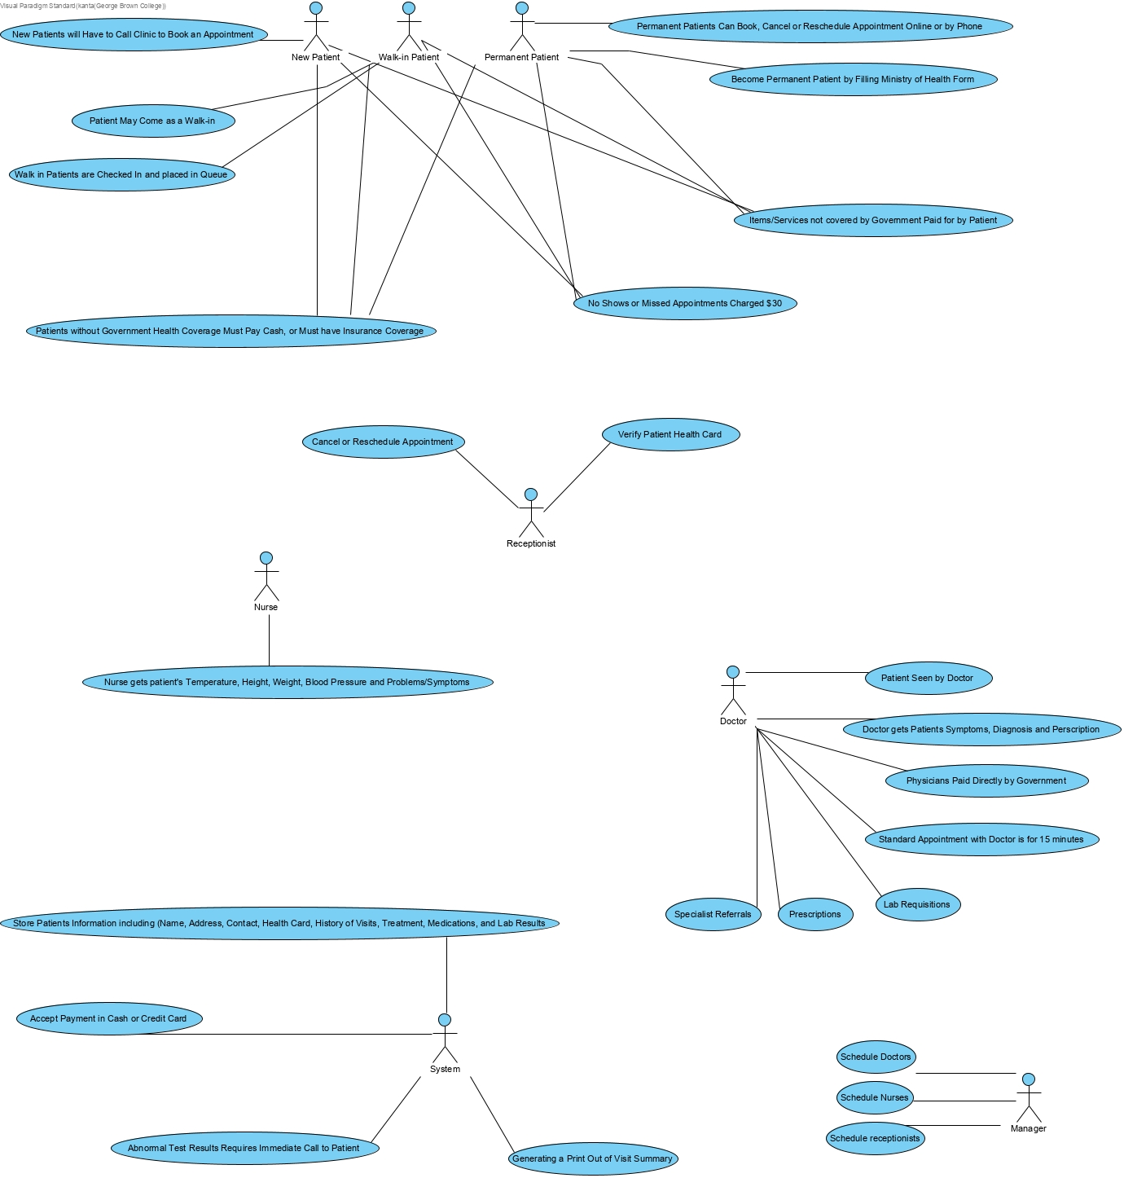

**Question 6:**

|  |
| --- |
| Use Case Title: Become permanent patient |
| Primary Actor: New patient |
| Level: Kite |
| Stakeholders: Customer, ABC Clinic |
| Precondition: Fill Ministry of Health form |
| Minimal Guarantee: Maintain new patient status |
| Success Guarantees: Become permanent patient |
| Trigger: Clinic sends Ministry of health form filled by patient |
| Main Success Scenario: |
|  |
| 1.       New patient books and appointment or comes in as walk-in patient |
| 2.       Receptionist assists patient fill out Ministry of Health form |
| 3.       Clinic sends form to Ministry of Health |
| 4.       Patient becomes permanent patient |
| Extensions: |
|  |
|  |
| Use Case Title: Permanent patient online booking |
| Primary Actor: Permanent patient |
| Level: Kite |
| Stakeholders: Customer, ABC Clinic |
| Precondition: Must be registered as permanent patient |
| Minimal Guarantee: Patient may view available time slots |
| Success Guarantees: Patient books, reschedules or cancels appointment online |
| Trigger: Permanent patient logs onto Clinic website |
| Main Success Scenario: |
|  |
| 1.       Patients is registered as a permanent patient |
| 2.       Permanent patient logs onto ABC Clinic website |
| 3.       Patient views available appointment time slots |
| 4.       Patient registers for their desired appointment time |
| 5.       Patient may reschedule or cancel appointment no later that 24 hours until appointment |
| Extensions: |
|  |
| Use Case Title: Items/Services not covered by OHIP |
| Primary Actor: Walk-in patient, new patient, permanent patient |
| Level: Kite |
| Stakeholders: Customer, ABC Clinic, Insurance company |
| Precondition: Item/Service must not be covered by OHIP |
| Minimal Guarantee: Patient may opt for similar service covered by OHIP |
| Success Guarantees: Patient pays for items/services not covered by OHIP |
| Trigger: Patient informed that items/services are not covered by OHIP |
| Main Success Scenario: |
|  |
| 1.       Patient requires items/services that are not covered by the government |
| 2.       Patient decides they will pay for items/services themselves |
| 3.       Patient decides to use third party insurance to pay for items/services |
| 4.       Patient fills out insurance form or pays via cash/credit card |
| Extensions: |
|  |
|  |
| Use Case Title: Nurse documents patient specifications |
| Primary Actor: Nurse |
| Level: Kite |
| Stakeholders: Customer, Nurse, ABC Clinic |
| Precondition: Patient must have appointment |
| Minimal Guarantee: Patient meets with Nurse |
| Success Guarantees: Nurse documents patients’ height, weight, temperature, blood pressure, concerns/symptoms |
| Trigger: Patient shows for appointment |
| Main Success Scenario: |
|  |
| 1.       Patient shows up for appointment |
| 2.       Receptionist marks patient as checked-in on system software |
| 3.       Nurse takes patient to examination room |
| 4.       Nurse document patient’s specifications |
| 5.       Nurse passes information onto doctor who will be next to see patient |
| Extensions: |
|  |
|  |
| Use Case Title: Verify patient health card |
| Primary Actor: Receptionist, new patient, permanent patient, walk-in patient |
| Level: Kite |
| Stakeholders: Customer, ABC Clinic |
| Precondition: Patient must come to clinic for medical services |
| Minimal Guarantee: Patient will be notified if they are covered by OHIP |
| Success Guarantees: Patient has a valid health card |
| Trigger: Patient must have health card |
| Main Success Scenario: |
|  |
| 1.       Patient comes to clinic for medical services |
| 2.       Patient presents health card to receptionist |
| 3.       Receptionist verifies validity of health card via software system |
| 4.       Patient is put in queue to see doctor |
| Extensions: |
|  |
|  |
| Use Case Title: Physician paid by government |
| Primary Actor: Physician |
| Level: Kite |
| Stakeholders: Physician, ABC Clinic |
| Precondition: Medical service covered by OHIP |
| Minimal Guarantee: Physician bills government |
| Success Guarantees: Physician gets paid for services rendered by government |
| Trigger: Physician submits form for services rendered |
| Main Success Scenario: |
|  |
| 1.       Physician logs onto clinic system |
| 2.       Physician fills electronical form for services rendered |
| 3.       Physician receives payment |
| Extensions: |
|  |
|  |
| Use Case Title: Specialist referral |
| Primary Actor: Patient |
| Level: Kite |
| Stakeholders: Customer, Physician |
| Precondition: Patient requires appointment with specialist |
| Minimal Guarantee: Physician will address patient’s concerns |
| Success Guarantees: Patient gets referral to see specialist |
| Trigger: Patient requires a medical specialist not available at ABC Clinic |
| Main Success Scenario: |
|  |
| 1.       Patient has appointment with physician |
| 2.       Physician determines patient needs to see a specialist |
| 3.       Physician fills appropriate referral form on system software |
| 4.       Physician sends request on patients’ behalf via system software |
| 5.       Patient get appointment to see spaecialist |
| Extensions: |
|  |
|  |
| Use Case Title: Patient given prescription |
| Primary Actor: Patient |
| Level: Kite |
| Stakeholders: Customer, ABC Clinic, Pharmacy |
| Precondition: Physician determines patient needs medication requiring a prescription |
| Minimal Guarantee: Physician addresses patients’ concern |
| Success Guarantees: Patient gets prescription filled |
| Trigger: Physician gives prescription for medication |
| Main Success Scenario: |
|  |
| 1.       Patient has appointment with physician |
| 2.       Physician determines that patient requires prescribed medication |
| 3.       Physician prints out prescription or sends prescription to pharmacist electronically |
| 4.       Patient goes to pharmacy to retrieve perscription |
| Extensions: |
|  |
|  |
| Use Case Title: Patient given lab requisition |
| Primary Actor: Patient, Physician, Laboratory |
| Level: Kite |
| Stakeholders: Customer, Physician, Laboratory |
| Precondition: Patient must require services provided by medical laboratory |
| Minimal Guarantee: Physician addresses patients’ concern |
| Success Guarantees: Patient has medical samples sent to laboratory |
| Trigger: Patient must consent to medical samples (blood, urine, etc.) being taken |
| Main Success Scenario: |
|  |
| 1.       Patient attends appointment with physician |
| 2.       Physician determines patient needs to submit medical samples for testing |
| 3.       Physician fills lab requisition form and gives print out copy to patient |
| 4.       Patient goes to appropriate medical laboratory |
| 5.       Patient submits medical samples |
| 6.       Results sent to physician electronically |
| Extensions: |
|  |
|  |
| Use Case Title: Abnormal test results given patient |
| Primary Actor: Patient |
| Level: Kite |
| Stakeholders: Customer, ABC Clinic, Medical Laboratory |
| Precondition: Patient submitted medical samples to laboratory |
| Minimal Guarantee: Physician addresses patients’ concerns |
| Success Guarantees: Physician informs patient of results in a follow up appointment |
| Trigger: Abnormal test results sent from laboratory to physician in charge |
| Main Success Scenario: |
|  |
| 1.       Medical Laboratory performs tests on medical samples |
| 2.       Abnormal result immediately sent to physician in charge |
| 3.       Physician review abnormal results |
| 4.       Receptionist informs patient that they must see the doctor in a follow up appointment |
| 5.       Patient arrives for follow up appointment |
| 6.       Physician discusses abnormal results with patients and makes recommendations |
| Extensions: |
|  |

**Question 7:**

Book Appointment

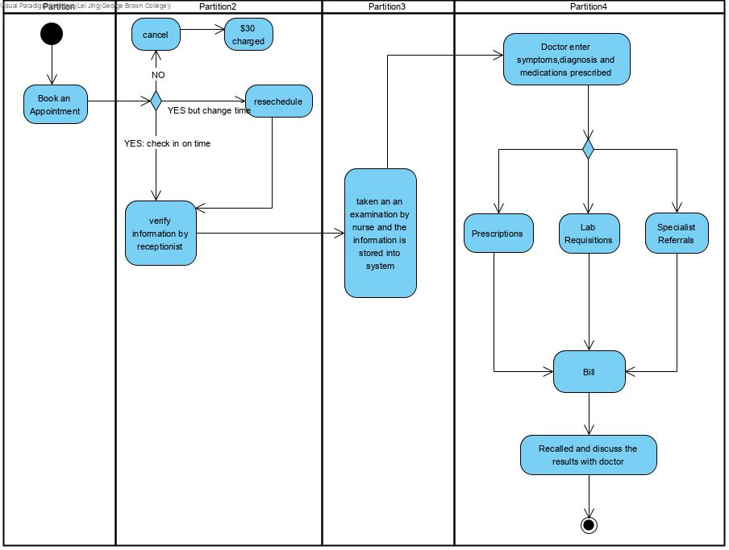

Store Patients Information

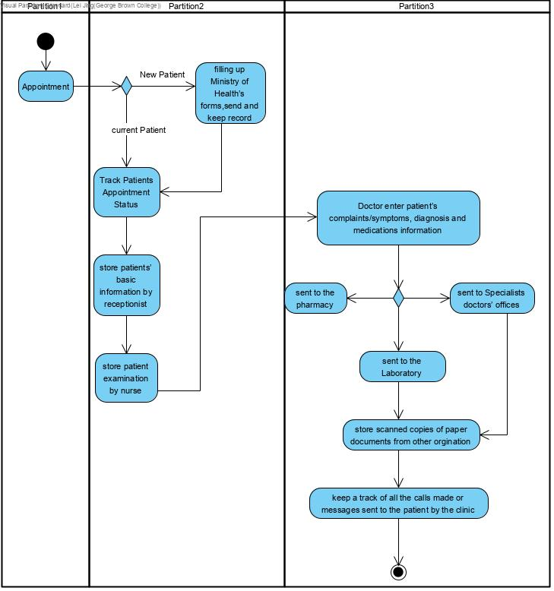

Walk In

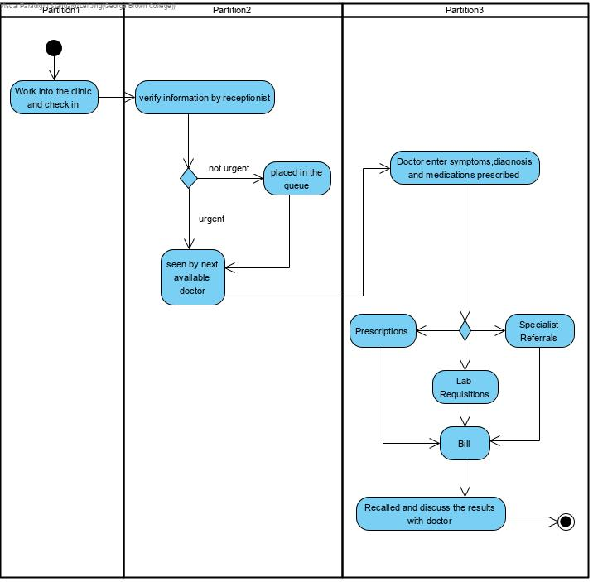

**Question 8:**

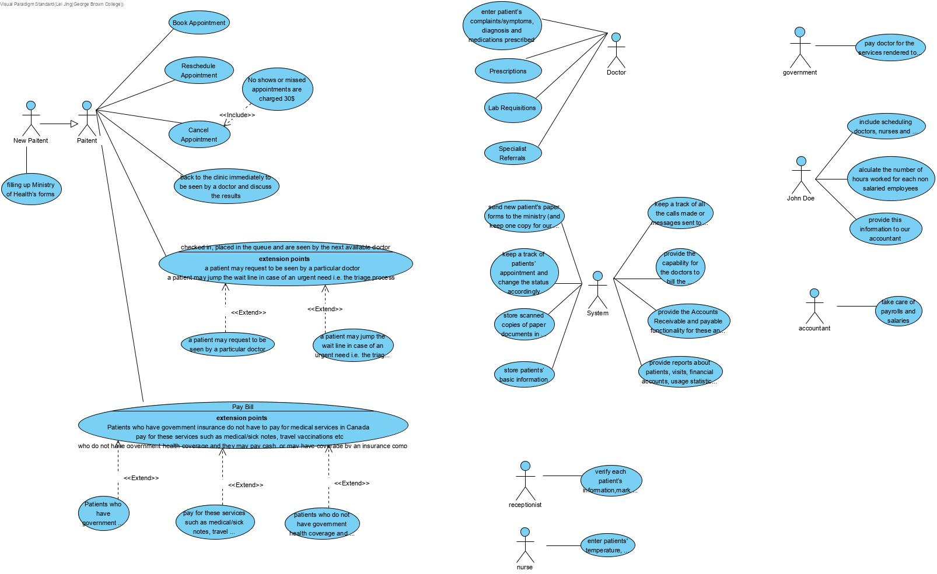

**Question 9:**

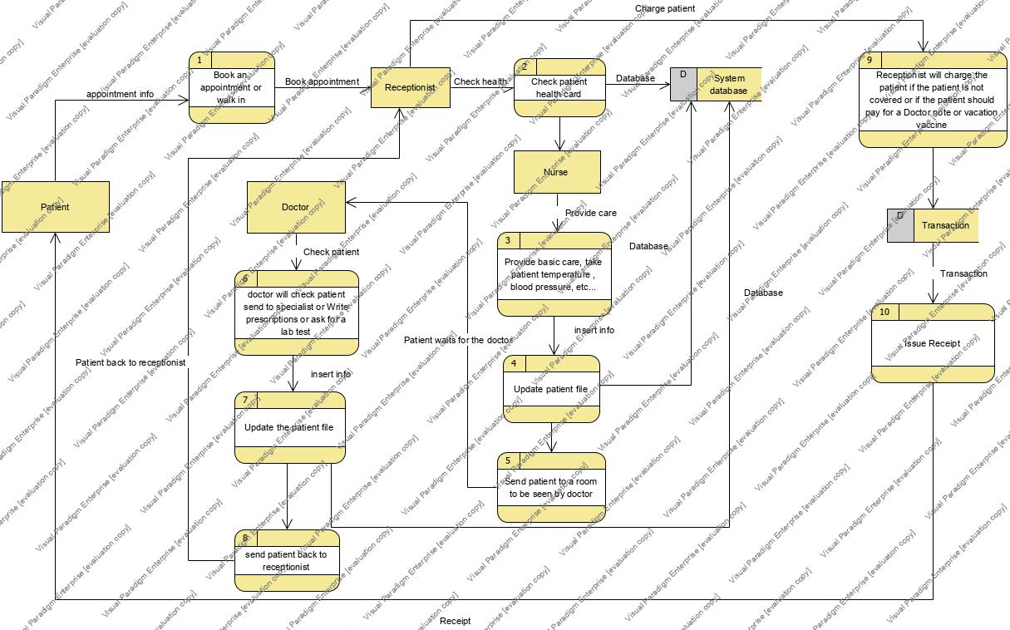

**Question 10:**

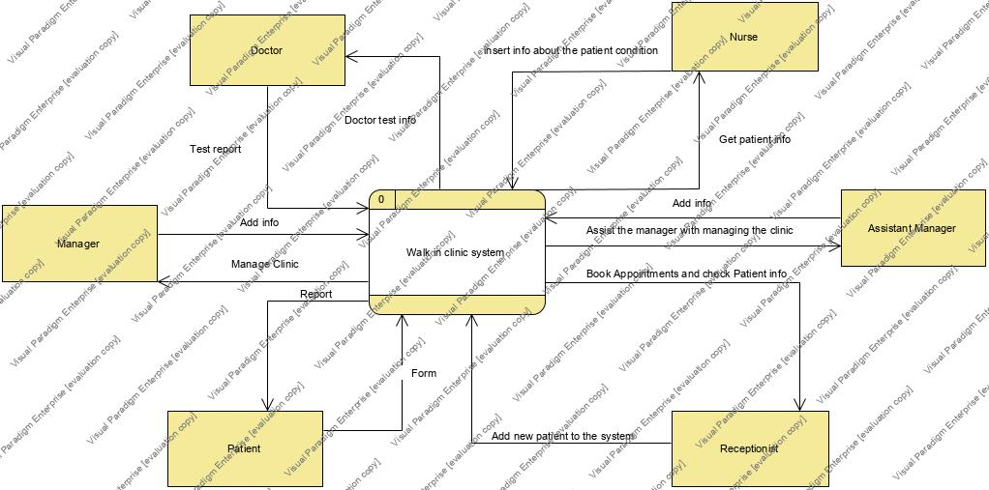

**Question 11:**

|  |  |  |  |  |  |
| --- | --- | --- | --- | --- | --- |
|  | | 1 | 2 | 3 | 4 |
| Conditions | Patient own health card | Y | N | Y | N |
| Patient registered at the clinic | Y | Y | N | N |
| Actions | Patient must pay for visits |  | X |  | X |
| Patient can book an appointment | X | X |  |  |
| Patient should pay for Doctor note | X | X | X | X |
| Patient can visit the clinic | X | X | X | X |

**Question 12:**

Doctor

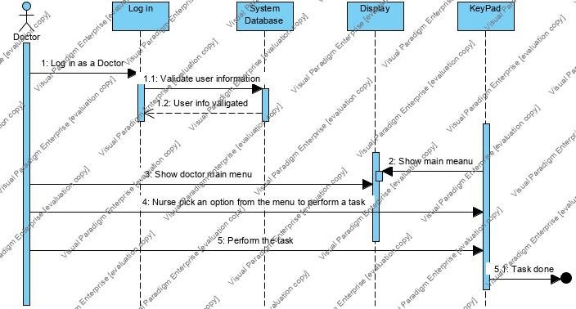

Manager

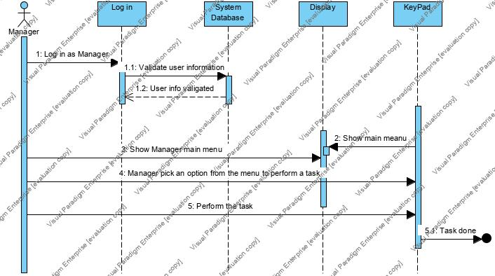

Nurse

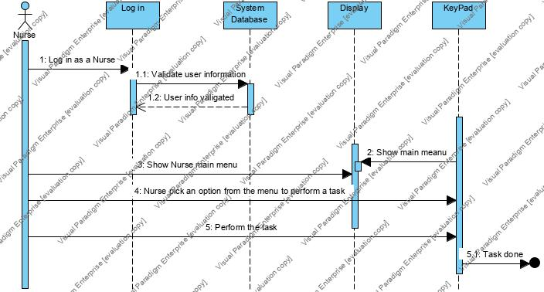

**Question 13:**

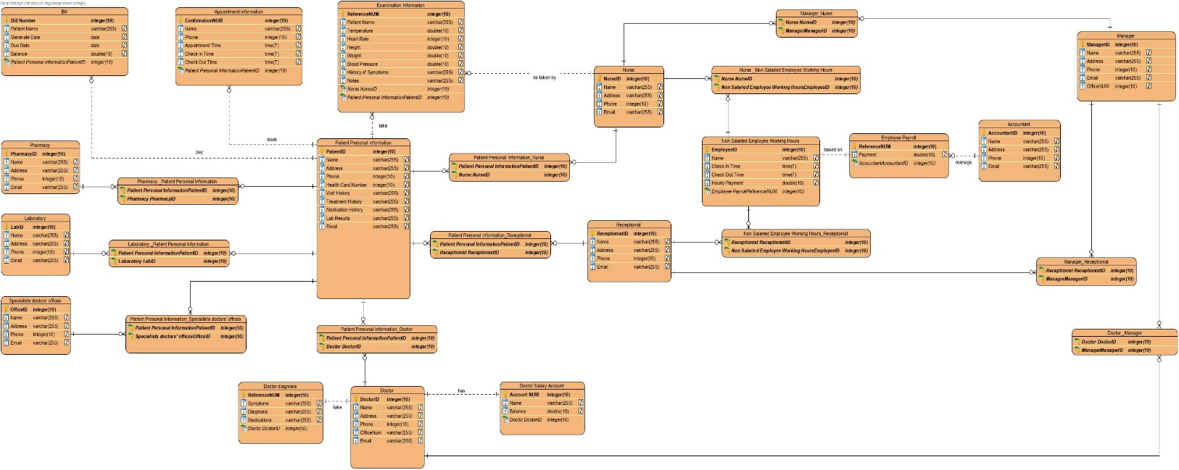

**Question 14:**

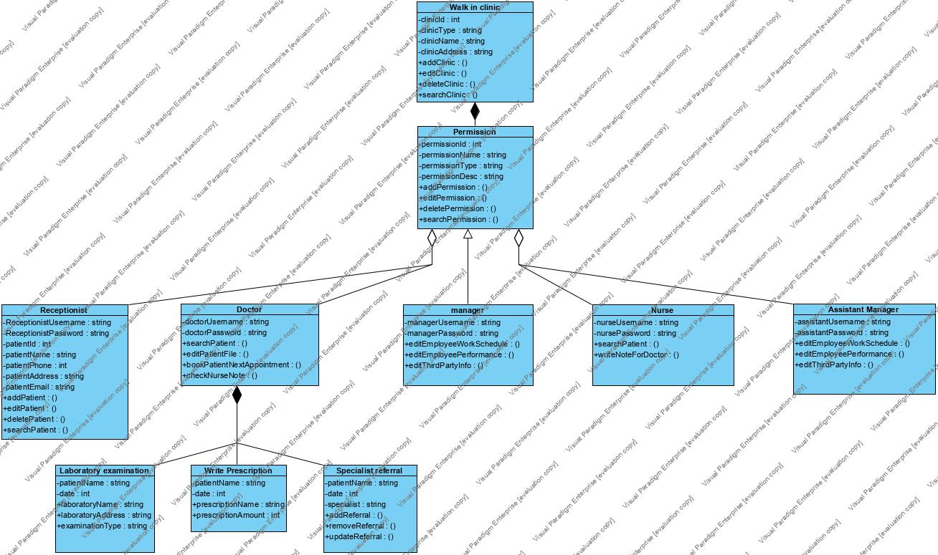

**Question 15:**

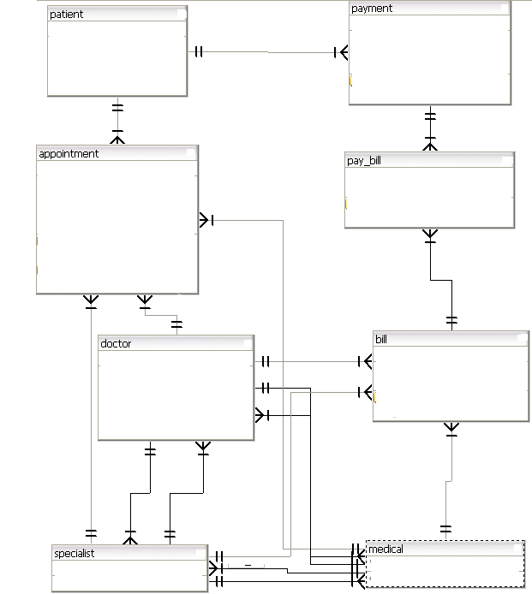

**Question 16:**

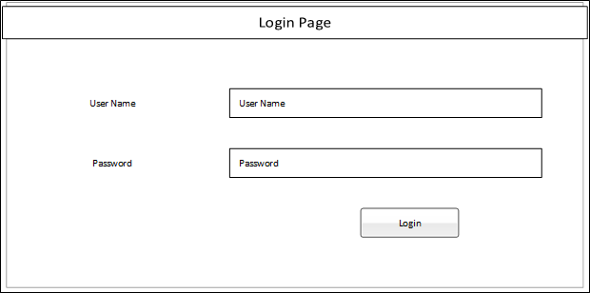

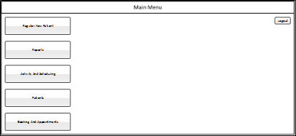

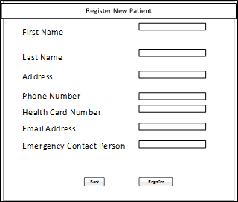

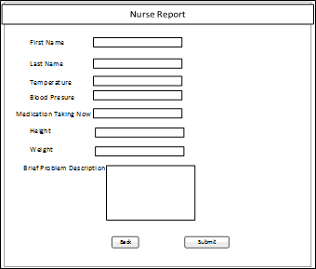

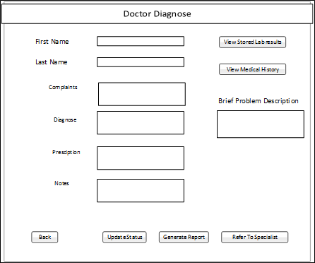

**Question 17:**

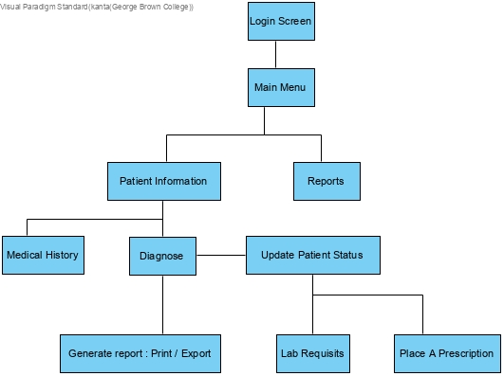

**Question 18:**

|  |  |
| --- | --- |
| Testing Strategy |  |
| 1.0 INTRODUCTION | 5.0 Hardware Requirements |
| 2.0 OBJECTIVES AND TASKS | Computers |
| 2.1 Objectives | Network |
| 2.2 Tasks | 6.0 Environment Requirements |
| 3.0 SCOPE | 6.1 Interfaces |
| - what is being tested | 6.2 Functionality |
| 4.0 Testing Strategy | 6.3 Third Party System Connection |
| 4.1 Basic Test | 7.0 CONTROL PROCEDURES |
| 4.2 System Integration Testing | Problem Reporting |
| 4.3 Performance | Document the modifications to the software |
| 4.4 User Interaction |  |